TITLE OF YOUR ABSTRACT (Calibri, Bold 14pt centered)

Author, A¹, Author, B² (Calibri 12pt centered)

¹Institution 1(Calibri 12pt centered)
²Institution 2 (Calibri 12pt centered)
E-mail (corresponding author)

- INTRODUCTION (headlines: Calibri Bold, 12pt)
Authors are requested to submit an abstract not exceeding two (2) pages in English.
The abstract must include the title, introduction, methods and results, conclusion and references. The manuscript should be prepared on an A4-sized paper with 25 mm margins on all sides and typed with single spacing using size 12 Calibri font. All illustrations must be prepared inside of the main text. All accepted papers will be published online in the conference book of abstract with ISBN number.

- METHODS AND RESULTS (headlines: Calibri, Bold, 12pt)

The methodology must be clearly stated and described in sufficient detail or with sufficient references. All the tables, images and figures should be centered. Figures and images should be numbered and figure headers should be placed under the figure or image; as for the tables, they should also be numbered and the table header should be placed at the top.

4.1 Equations
Equations should be centered and numbered consecutively, as in Eq. [1].

 | $$f\left(x\right)=a_{0}+\sum_{n=1}^{∞}{\left(a_{n}\cos{\frac{nπx}{L}}+b_{n}\sin{\frac{nπx}{L}}\right)}$$ | (1)

  - List
Lists can be provided using either numbers or bullets:
- List item 1 like this;
- List item 2 is an example of a longer list item that wraps to a second line, where the second line is indented.
The example for bulleted items like this:
- List item 1;
- List item 2.

  - Tables and figures
Tables and figures should appear in one column of a page and be numbered consecutively. Figures and texts should appear on the same page, and a centered caption should appear directly beneath the figure. It is preferable that figures be mounted in portrait style and figure captions are no longer than two lines. On figures showing graphs, both axes must be clearly labeled (including units if applicable).
Tables should be designed to have a uniform style throughout the paper, following the style shown in Table 1. Table captions should be in 10pt “Calibri” bold, centered, and the texts in Table should be set in 9pt “Calibri” font.

Table 1. Caption heading for a table should be placed at the top of the table and within table width.
 | A | B | C | D
A | Aa | Ab | Ac | Ad
B | Ba | Bb | Bc | Bd
C | Ca | Cb | Cc | Cd
D | Da | Db | Dc | Dd
E | Ea | Eb | Ec | Ed

Authors should prepare their figures in color. Please prepare the figures in high resolution (at least 300 dpi). Pictures must be sharp enough otherwise they will be rejected. Figures must be originals, computer-generated or drafted, and placed within the text area where they are discussed. Figure 1 shows one example. Figure captions should be in 10pt “Calibri” font, bold, centered. When applicable, the texts in graphs, illustrations or images should be set in 8pt “Calibri” font.
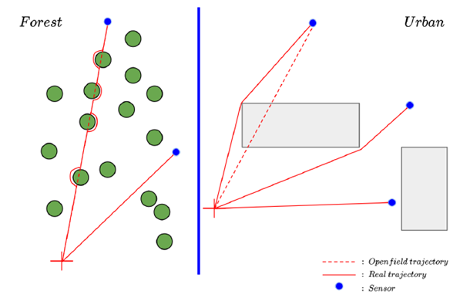
Figure 1. The caption heading for a figure should be placed below the figure and within figure/illustration width.

  - Units
Use SI as primary units. Always place the units in the parentheses.

- CONCLUSION (headlines: Calibri Bold, 12pt)
Conclusions should include the principles and generalizations inferred from the results, any exceptions to, or problems with these principles and generalizations, theoretical and/or practical implications of the work, and conclusions with further recommendations.

ACKNOWLEDGMENT (headlines: Calibri Bold, 12pt)
The authors would like to express appreciation for the support of the sponsors [Project Number = XXXXXXX].

REFERENCES (headlines: Calibri Bold, 12pt)
References should be listed arranged in order to as be used in the text beginning with the author’s names and initials, followed by the year of publication, title of the article, title of periodical, volume and page. Example:

[1] Svatos, J., Vedral, J.,: 2011, Using of Frequency Swept Signals for Metal Detection, 20th International Conference on Soft Magnetic Materials, Book of Abstract, Kos Island, pp. 144-145,

In the text, references should be cited with the number of the citation e.g. [1].

